Principle of Superposition and Resistive Sensors
(Final Report – Experiment #3)

Vega, Roberto Javier SID: 003 110 717
Partner: Eddie Esquivel
EE 110 L – fall 2003
LAB 3
Objectives:

-To learn and to demonstrate the principles of superposition.
-To check for the failure cases of superposition when power supply is not idea.
-To use a Wheatstone bridge circuit as thermometer using a thermistor.

Theory:

1) Superposition: It is a property of linear systems, which states that for any linear circuit containing more than one independent source, any circuit voltage or current may be calculated as the algebraic sum of the individual voltages or currents caused by each independent source acting alone:
f (x + y) = f (x) + f (y)

2) Wheatstone Bridge Circuit:

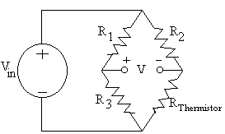
V = V_{in} (ΔR_{Thermistor}/2R₂) + ΔV_{in} (ΔR_{Thermistor}/2R₂)

3) Thermistors: temperature sensitive resistors, which resistances may go up or down with an increasing temperature. For our specific case, the resistance showed in the experiment when down, therefore providing a negative factor for resistance.

4) Potentiometers: variable resistors that are used to test for different responses of a circuit.

Procedure:

Part 1:

The following circuit was set up on the proto-board:

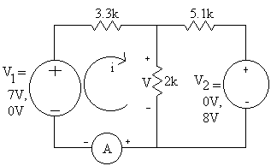

Part 2:

After setting up the following circuit, V was measured.

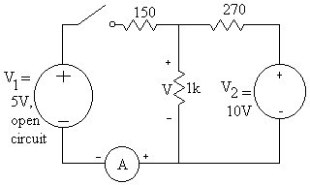

Part 3:

The circuit below was set up.

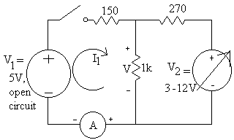

Part 4:
First, R₇₀ and R₉₈ were measured. Then, the circuit below was set up.
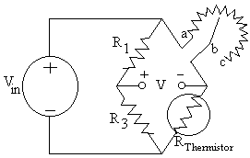

At temperature equaled room temperature, V_{in} was set to be 10V and R₁, R₂, R₃ were chosen as close to R₇₀ as possible. Then, the bridge was balanced by R₂ to make V was around 0V at room temperature as well. V and R₂ were measured and recorded into the data-sheet.

Pre Lab Calculations:

- Attached at the end of this report.

Data Obtained Experimentally:

Part I:
R₁ = 3.5KΩ
R₂ = 5.1KΩ
R₃ = 1.9KΩ
8V source 7V source
Disconnected disconnected
V₁ = 6.98V V₂ = 7.99V
V₃’ = 2.00V V₃’’ = 1.58V
I₃’ = 1.02mA I₃’’ = 0.8mA

Part II:
R₁ = 149.9Ω
R₂ = 274.0Ω
R₃ = .99KΩ
-Voltage across 1KΩ resistor as measured = 6.6V
-Voltage across 1KΩ resistor as calculated in Pre-Lab = .33V
If polarity of 7V source is reversed then voltage is .28V
Part III:

V_{S2} (Volts) | V_{S1} (Volts) | I (mA)
3 | 5.013 | 7.10
4 | 5.013 | 5.02
5 | 5.013 | 2.94
6 | 5.013 | 0.68
7 | 5.013 | -1.28
8 | 5.014 | -3.43
9 | 5.163 | -5.27
10 | 5.735 | -5.87
11 | 6.289 | -6.54
12 | 6.940 | -7.02

Part IV:

R₁ + R₂ + R₃ = 24KΩ R_{TH} @ Room Temperature = 27.6KΩ
V_{IN} = 5V for V = 0.5V(Pinch R_{TH})
V_{IN} = 5.5V => 0.54V
V_{IN} = 4.5V => 0.40V

Data Analysis:

In the first part of the lab the errors detected where minimal. We started by disconnecting the 8V source and shorted the two terminals. The values obtained where expected to be 2.12V and 1.06mA and ours were very similar to those ones. Our percent error of was 5.66% voltage and a 3.92% for current. We continued with the experiment by disconnecting the 7V source and shorted its two terminals. We measured 1.58V and 0.8mA for the 2k resistor. The error percent was 0.6% in voltage and 2.5% in current.
The sum the two voltage component was 3.58V for the 2KΩ resistor, and for the two current components was 1.82mA. Our percent error was 2.98% for voltage and a 1.08% for current.
In the second part, the measured V_{1k}, which was 6.6V, was different from the calculated V_{1k}, which was 6.19V according to the superposition principle. The superposition principle failed here because the power supplies were not ideal. The superposition principle worked with independent sources; however, the power supplies were not independent in the circuit. When the voltage supplies, which had already been set up, were connected the circuit, V₂ was the main voltage supply. As a result, current flowed from V₂, divided into the V₁ and 1kΩ branches, and returned to V₂.
In the third part of the experiment, V₂ was increased from 3V to 12V, and V₁ vs I₁ was plotted. From this graph, the change of main voltage supply from V₁ to V₂, where the current started flowing, was shown by the change of I₁ from positive to negative. This helped explain the failure of superposition principle in part two of this experiment.

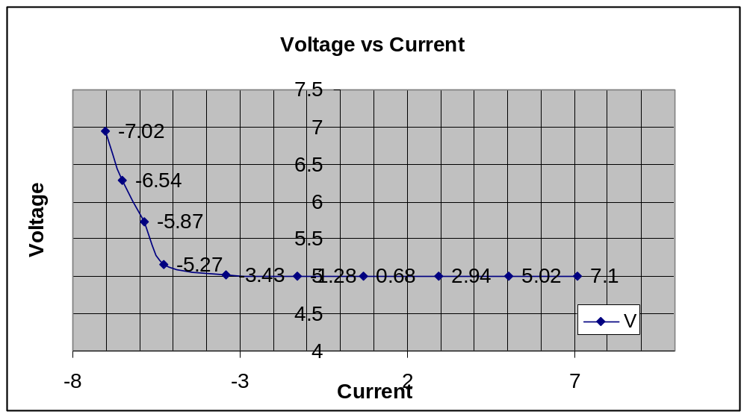

In the forth part of the experiment, a Wheatstone bridge was used as a temperature sensor. This was done by measuring the output voltage, V, which was close to 0V at room temperature and close to 0.5V at body temperature under the circuit design.
Discussion:

Answers:
1.- In the thermistor circuit, one of the restriction is that all the resistor must be in a close range of values when compared to the actual resistance value of the sensor. This is because of power dissipation. If the values were to be too different, then the power would not be dissipated consistently and evenly among all the resistors, therefore the heat of the power dissipated could affect the role of the sensor. Another important factor is the value of the resistances, they should be consistent with in their ratios: R1/R2 = R3/R4 as stated in the pre lab.

2.- Graph

Output at room temperature: 0 V
Output at body temperature: .5 V

3.- The Trojans weren’t right. This is because the superposition principle was not applied following kicchoff’s laws. It is impossible to assume a current that flows with the two potential differences being inconsistent. In other to correct their circuit, it was needed to switch the polarity of on the voltage sources. This way, the voltages differences where consistent with the laws of physics as well.

4.- The circuit was receiving the current instead of giving it to the other elements. This is because the sources allow this type of effect to happen. In the other hand, this could not possible happen with batteries because they don’t allow current to flow inside of the source. Their polarities are not interchangeable.
Conclusion:

In conclusion, the experiment was successful, because all the objectives were achieved properly. In the first part, the superposition principle was shown. The second part of the experiment demonstrated that the superposition principle failed when the power supply was not ideal. The third part of the experiment helped explain the situation in part two. And finally, in the forth part the Wheatstone bridge was used as a thermometer circuit, in where it indicated the surrounding temperature through the output voltage.

